SIMATS ENGINEERING
Department of Computer Science and Engineering
ASSESSMENT TOOL 1 – EXPERIMENTS
Course Code: | CSA12 | Course Title: | Computer Architecture
CO Assessed: | CO3 – Precision (BL3) | Assessment: | Experiments
Weightage: | 45% | Total Marks: | 100
CO3 Statement: | Design processor organization by constructing pipelined datapath structures, identifying hazard types (data, control, structural), and comparing superscalar techniques such as out-of-order execution, speculative execution, and simultaneous multithreading (SMT).
Student Name: | P.Rishitha | Reg. No.: | 192472396
Section / Batch: | 2024 | Date: | 10/08/2026

Instructions to Students
• Identify the relevant concepts of register transfers, ALU operations, bus organization, pipelining, hazards, and superscalar processing.
• Analyze the execution of data transfers, arithmetic and logic operations, instruction processing, and parallel execution.
• Apply suitable techniques such as multiple buses, pipelining, stalling, forwarding, branch prediction, and speculative execution.
• Compute performance measures such as execution time, clock cycles, speedup, throughput, and resource utilization.
• Interpret the results by evaluating performance improvements, bottlenecks, and the suitability of each architectural technique.

QUESTIONS
1. Analyze a processor datapath that performs register transfers and logical operations such as XOR, NOT, and comparison, and examine the control signals and execution sequence required for each operation.
2. Develop a bus-based system for transferring data between the processor, memory, and I/O devices, and analyze how bus width, transfer rate, and bus contention influence system performance.
3. Simulate a pipelined processor with arithmetic, memory, and branch instructions, and evaluate the effects of pipeline depth on execution time, throughput, and overall speedup.
4. Construct a pipeline containing instruction dependencies and branch conditions, and analyze the performance impact of data and control hazards using stalling, forwarding, and branch prediction techniques.
5. Develop a superscalar processor model that supports multiple execution units and out-of-order instruction processing, and evaluate how instruction scheduling and resource allocation improve instruction throughput.
Code of Conduct
I P.Rishitha (192472396) (Name / Reg No) certify that this submission is my original work and that I have adhered to the guidelines specified for this assessment. I understand that any violation of academic integrity rules will result in disciplinary action.
Signature of the Student: P.Rishitha
RUBRICS FOR CALCULATION
Criteria | Weightage(%) | Level 4 – Exemplary (5 Marks) | Level 3 –  Proficient (4  Marks) | Level 2 –  Developing  (2–3 Marks) | Level 1 – Beginning (0–1 Mark)
Understanding of Concepts | 25 | Demonstrates  thorough  understanding and effectively integrates multiple  concepts/technologies | Good  understanding  with proper  integration of  most concepts | Basic  understanding;  limited or partial integration | Poor understanding; unable to integrate concepts
Experimental Design | 30 | Well-planned,  systematic  implementation with optimal solution | Correct  implementation with minor issues | Basic  implementation  with errors or  inefficiencies | Incorrect or  incomplete  implementation
Use of Tools | 20 | Effective and  advanced use of  tools/technologies with proper  configuration | Appropriate use of tools with  correct execution | Limited or  inconsistent use of tools | Incorrect or minimal use of tools
Analysis of  Results | 15 | Insightful analysis with accurate  interpretation and  validation of results | Good analysis  with reasonable interpretation | Basic analysis  with limited  insights | Poor or incorrect analysis of results
Documentation | 10 | Clear, well-structured documentation with diagrams, code, and results | Organized  documentation with necessary  details | Basic  documentation  with missing  details | Poor or incomplete documentation

Marks Evaluation:
Q.  No | Understanding of Concepts(25) |  | Experimental Design (30) | Use of  Tools(20) | Analysis of  Results (15) | Documentation (10) | Total  (out of 100)
1 | / 4 |  | / 4 | / 4 | / 4 | / 4
2 | / 4 |  | / 4 | / 4 | / 4 | / 4
3 | / 4 |  | / 4 | / 4 | / 4 | / 4
4 | / 4 |  | / 4 | / 4 | / 4 | / 4
5 | / 4 |  | / 4 | / 4 | / 4 | / 4
 | / 25 |  | / 30 | / 20 | / 15 | / 10 | / 100

Course Coordinator Faculty Incharge

EXPERIMENT 1: Processor Datapath for Register Transfer and Logical Operations

Aim
To design and analyze a processor datapath that performs register transfers and logical operations such as XOR, NOT, and comparison, and to study the control signals and execution sequence.

Requirements
- Computer/Laptop
- Python
- Python IDLE
- Basic knowledge of CPU datapath and ALU

Theory
A processor datapath consists of registers, buses, an ALU and a control unit. Registers store temporary data, while the ALU performs arithmetic and logical operations.

Procedure
- Initialize processor registers.
- Load data into registers.
- Select the required registers as ALU inputs.
- Select the required ALU operation.
- Execute XOR, NOT or comparison.
- Store the result in the destination register.
- Update status flags for comparison.
- Display the register values and operation results.

Algorithm
1. Start
2. Initialize registers R0–R7
3. Load values into R1 and R2
4. Perform R3 = R1 XOR R2
5. Perform R4 = NOT R1
6. Compare R1 and R2
7. Set Zero/Negative/Carry flags
8. Display results
9. Stop

Expected Result
The processor datapath successfully performs register transfers, XOR, NOT and comparison operations according to the generated control signals.

Conclusion
The processor datapath and control sequence required for logical operations were successfully analyzed.
IMPLEMENTATION :
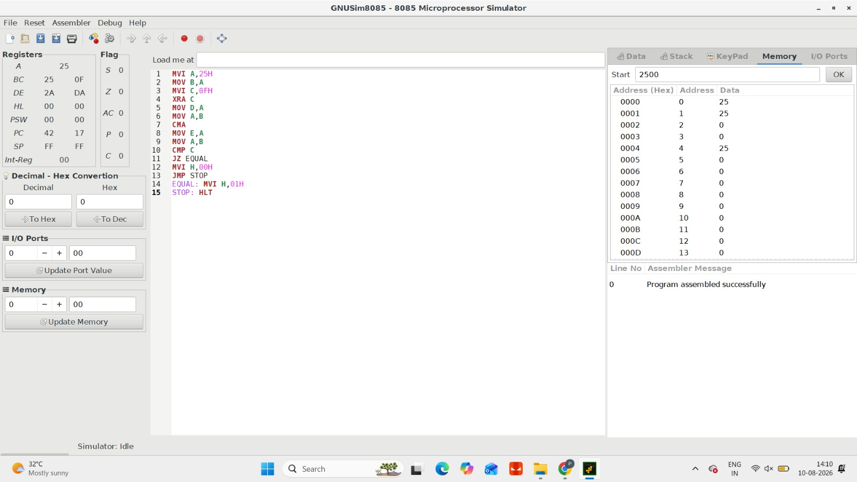

EXPERIMENT 2: Bus-Based System for CPU, Memory and I/O

Aim
To develop a bus-based system for transferring data between the processor, memory and I/O devices, and analyze the effects of bus width, transfer rate and bus contention.

Requirements
- Computer/Laptop
- Python
- Python IDLE

Theory
A system bus provides communication between the CPU, memory and I/O devices.
It consists of:
- Address Bus – carries addresses.
- Data Bus – carries data.
- Control Bus – carries control signals such as Read and Write.
The performance of a bus depends on its width and transfer rate.

Procedure
- Define CPU, memory and I/O devices.
- Create address, data and control buses.
- Transfer data from CPU to memory.
- Transfer data from memory to CPU.
- Perform I/O data transfers.
- Change the bus width.
- Measure the transfer time.
- Introduce multiple devices requesting the bus.
- Analyze bus contention.
- Compare the performance.

Algorithm
1. Start
2. Initialize CPU, Memory and I/O
3. Create system bus
4. Set bus width
5. Transfer data between CPU and Memory
6. Transfer data between CPU and I/O
7. Calculate transfer rate
8. Simulate bus contention
9. Compare different bus widths
10. Display results
11. Stop
Expected ResultE
A wider and faster bus provides higher data-transfer performance, while bus contention reduces overall system performance.

Conclusion
The bus-based communication system was successfully developed and the effects of bus width, transfer rate and contention were analyzed.
IMPLEMENTATION :
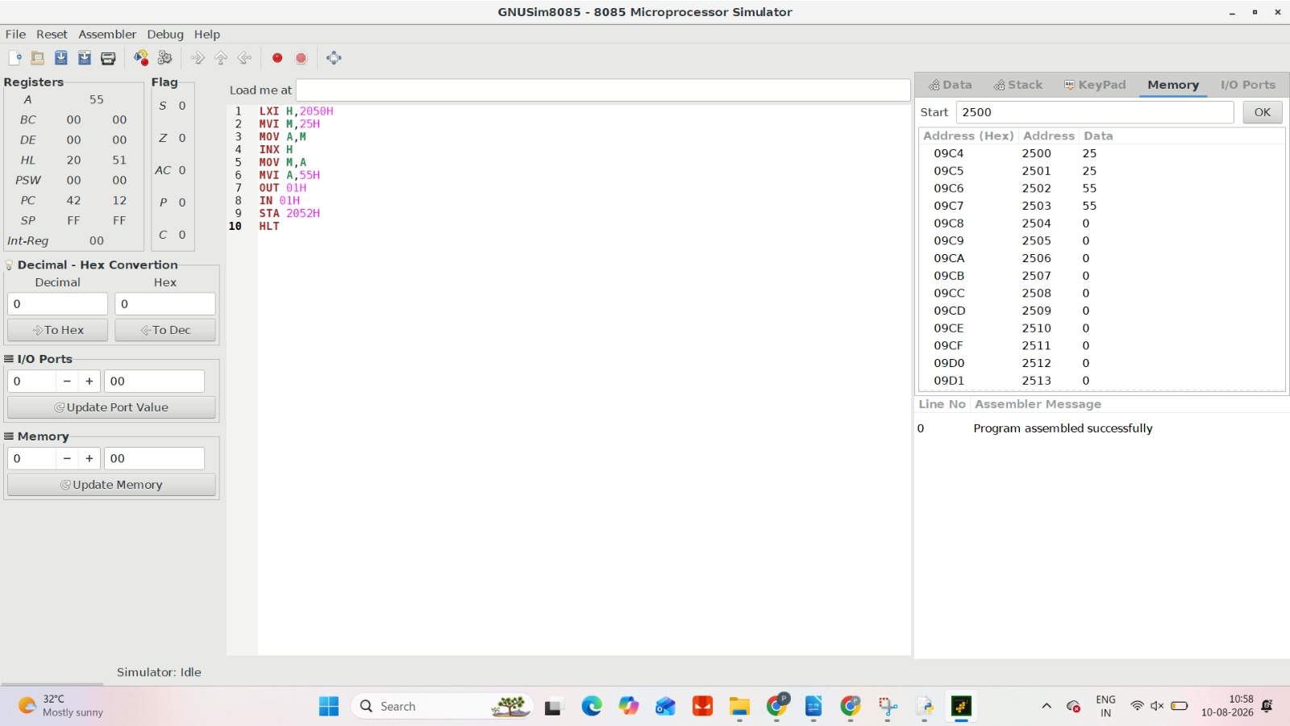

EXPERIMENT 3: Simulation of a Pipelined Processor

Aim
To simulate a pipelined processor containing arithmetic, memory and branch instructions and evaluate the effects of pipeline depth on execution time, throughput and speed up.

Requirements
- Computer/Laptop
- Python
- Python IDLE

Theory
Instruction pipelining divides instruction execution into multiple stages.
Where:
- IF – Instruction Fetch
- ID – Instruction Decode
- EX – Execute
- MEM – Memory Access
- WB – Write Back
Pipelining allows multiple instructions to be processed simultaneously.

Procedure
- Define the pipeline stages.
- Create arithmetic, memory and branch instructions.
- Execute the instructions without pipelining.
- Calculate the execution time.
- Execute the same instructions using a pipeline.
- Change the pipeline depth.
- Calculate execution time for each depth.
- Calculate throughput and speedup.
- Compare the results.

Expected Result
Pipelining reduces the total execution time for multiple instructions and increases instruction throughput.

Conclusion
The pipelined processor was successfully simulated and the relationship between pipeline depth, execution time, throughput and speedup was analyzed.

IMPLEMENTATION :
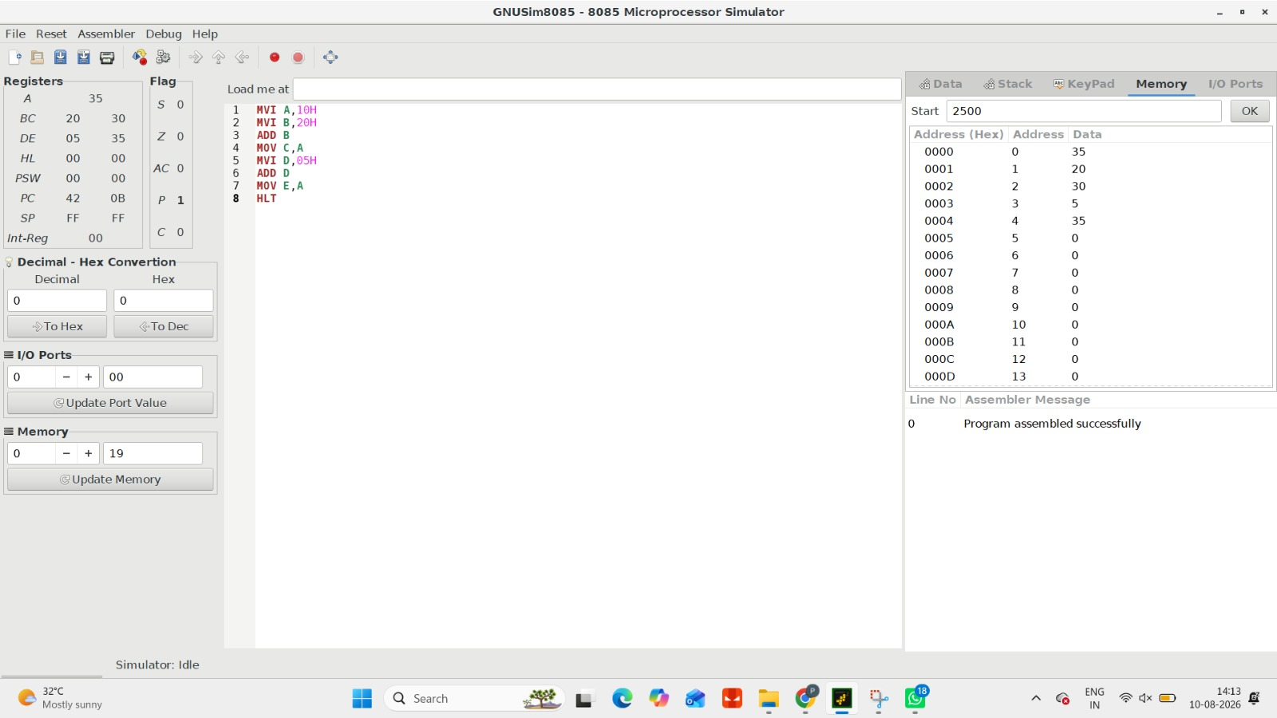

EXPERIMENT 4: Pipeline Hazards Using Stalling, Forwarding and Branch Prediction

Aim
To construct a pipelined processor containing instruction dependencies and branch conditions and analyze data and control hazards using stalling, forwarding and branch prediction.

Requirements
- Computer/Laptop
- Python
- Python IDLE

Theory
A pipeline hazard occurs when the next instruction cannot execute normally because of a dependency or branch.

Hazard Handling
Stalling: Temporarily stops pipeline execution.
Forwarding: Sends the result directly from one pipeline stage to another.
Branch Prediction: Predicts whether a branch will be taken.

Procedure
- Create a five-stage pipeline.
- Define instructions with data dependencies.
- Introduce a data hazard.
- Execute the instructions using stalling.
- Measure the number of cycles.
- Apply forwarding.
- Compare execution time.
- Introduce a branch instruction.
- Apply branch prediction.
- Calculate the branch penalty.
- Compare all techniques.
Algorithm
1. Start
2. Initialize pipeline
3. Load dependent instructions
4. Detect data hazard
5. Apply stalling
6. Calculate execution cycles
7. Apply forwarding
8. Calculate improved cycles
9. Introduce branch instruction
10. Apply branch prediction
11. Calculate branch penalty
12. Compare results
13. Stop
Expected Result :
Stalling → Higher execution time
Forwarding → Lower execution time
Prediction → Reduced branch penalty

Conclusion
Data and control hazards were successfully analyzed, and forwarding, stalling and branch prediction were evaluated for improving pipeline performance.
IMPLEMENTATION :
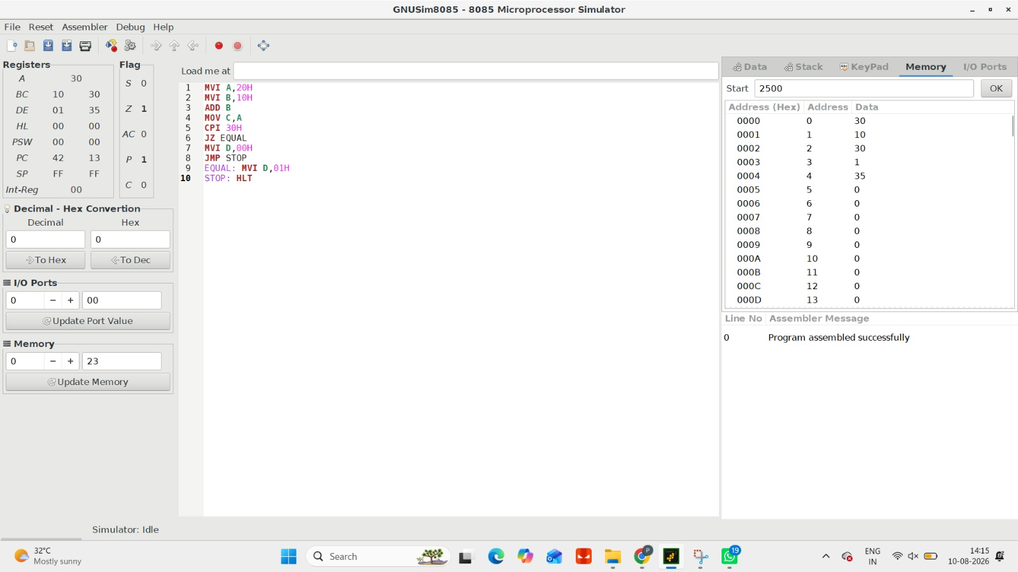

EXPERIMENT 5: Superscalar Processor with Out-of-Order Execution

Aim
To develop a superscalar processor model with multiple execution units and out-of-order instruction processing, and evaluate how instruction scheduling and resource allocation improve instruction throughput.

Requirements
- Computer/Laptop
- Python
- Python IDLE

Theory
A superscalar processor can execute multiple instructions during the same clock cycle by using multiple execution units.

Procedure
- Define multiple execution units.
- Create a sequence of instructions.
- Identify instruction dependencies.
- Create an instruction scheduler.
- Allocate instructions to available execution units.
- Execute independent instructions out of order.
- Maintain correct final program order.
- Calculate instructions completed per cycle.
- Compare single-unit and superscalar execution.
- Analyze throughput improvement.
Algorithm :
1. Start
2. Initialize execution units
3. Load instructions
4. Detect dependencies
5. Check available resources
6. Schedule ready instructions
7. Execute instructions out of order
8. Write results
9. Maintain correct instruction completion order
10. Calculate throughput
11. Compare with normal processor
12. Stop

Expected Result
The superscalar processor executes multiple independent instructions simultaneously, increasing instruction throughput and reducing total execution time.

Conclusion
A superscalar processor with multiple execution units and out-of-order execution was successfully analyzed, demonstrating improved instruction throughput through effective instruction scheduling and resource allocation.
IMPLEMENTATION :
